4/13 Math Questions and Answers

Example of work is on #1 and #3

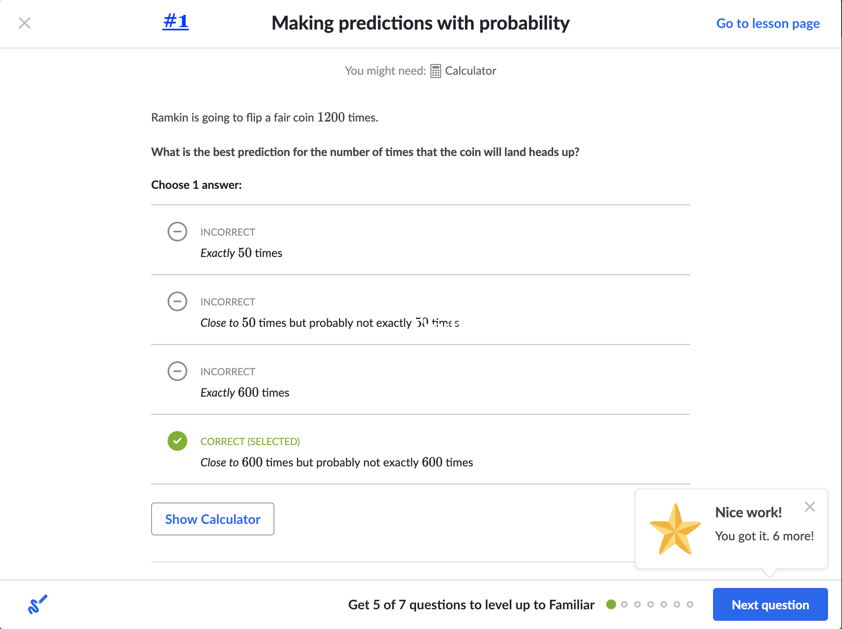

#1 work

<math xmlns="http://www.w3.org/1998/Math/MathML"><mi>B</mi><mi>e</mi><mi>s</mi><mi>t</mi><mo>&#xA0;</mo><mi>P</mi><mi>r</mi><mi>e</mi><mi>d</mi><mi>i</mi><mi>c</mi><mi>t</mi><mi>i</mi><mi>o</mi><mi>n</mi><mo>&#xA0;</mo><mo>=</mo><mo>&#xA0;</mo><mi>N</mi><mi>u</mi><mi>m</mi><mi>b</mi><mi>e</mi><mi>r</mi><mo>&#xA0;</mo><mi>o</mi><mi>f</mi><mo>&#xA0;</mo><mi>t</mi><mi>r</mi><mi>i</mi><mi>a</mi><mi>l</mi><mi>s</mi><mo>&#xA0;</mo><mo>&#xD7;</mo><mo>&#xA0;</mo><mi>P</mi><mfenced><mrow><mi>L</mi><mi>a</mi><mi>n</mi><mi>d</mi><mi>s</mi><mo>&#xA0;</mo><mi>t</mi><mi>a</mi><mi>i</mi><mi>l</mi><mi>s</mi><mo>&#xA0;</mo><mi>u</mi><mi>p</mi></mrow></mfenced></math>

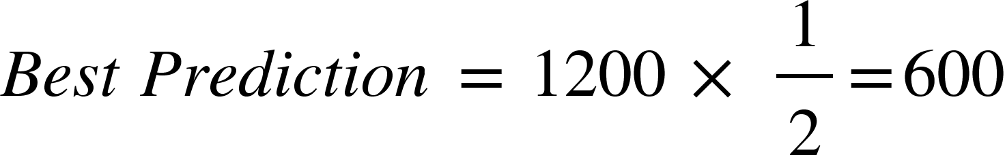

We should not predict *exactly* how many times the coin will land tails up because flipping a coin is random. It is impossible to make exact predictions for outcomes of random events.

The best prediction is that the coin will land tails up close to 225 times but probably not exactly 225 times.

